ClarityCompass – Comprehensive User Guide
Documentation for NGO Platform & Shared Portal

Contents
1. Introduction 1
2. NGO Platform User Guide 1
2.1. Accessing the NGO Platform 1
2.2. Dashboard 2
2.3. Strategic Plan 3
2.4. Results Framework 5
2.5. Programs 5
2.6. Projects 5
3. Key Activities 7
4. Indicators & Targets 8
5. Task Manager 9
6. Task QA (Quality Assurance) 10
7. AI Reports / Evaluation 11
8. Data Collection 13
8.1. AI Reporter 14
9. Shared Portal User Guide 15
9.1. Accessing the Shared Portal 15
9.2. Proposal Collaboration 15
9.3. Report Sharing 16
9.4. Communication Tools 16
10. Support & Troubleshooting 17
11. Glossary of Key Terms 17

Introduction
Welcome to ClarityCompass, a modern Monitoring, Evaluation, Accountability, and Learning (MEAL) and project management platform for NGOs.
ClarityCompass supports organizations in aligning strategy with implementation through two integrated environments:
Platform | Purpose
NGO Platform | Internal workspace for planning, project management, M&E, reporting, and task execution.
Shared Portal | Collaboration space where NGOs engage with external partners on proposals and reports.
This guide provides a comprehensive step-by-step walkthrough for NGO teams and collaborating partners using the Shared Portal.
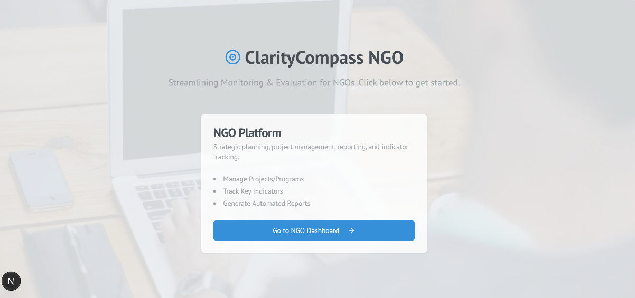

NGO Platform User Guide
The NGO Platform is your internal command center for planning, managing, and evaluating all organizational and project-level work.

Accessing the NGO Platform
- Go to the ClarityCompass home page.
- Select NGO Platform.
- Log in with your NGO credentials.
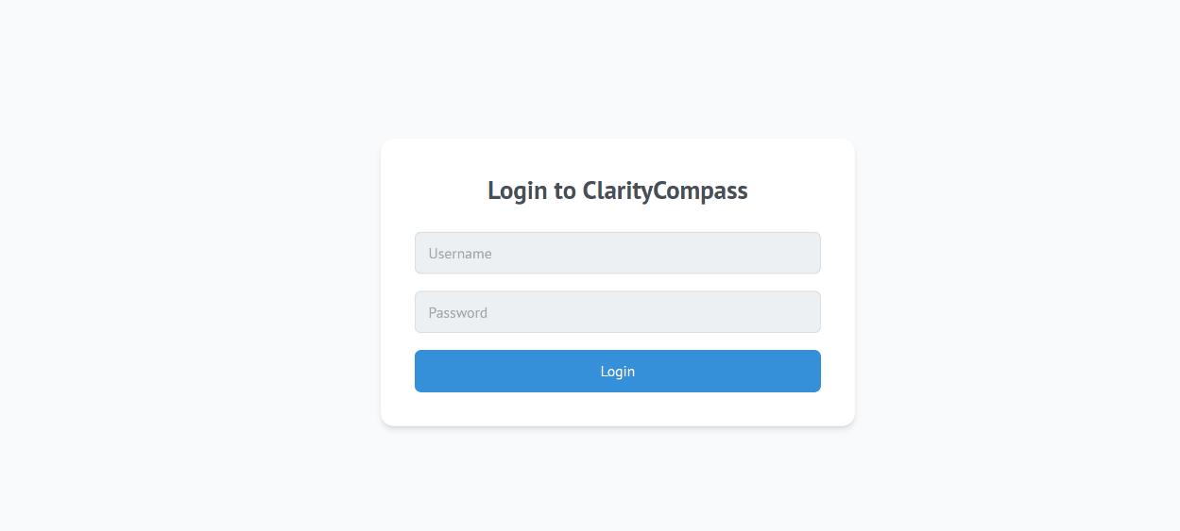
- The Dashboard will load automatically after login.

Dashboard
Your Dashboard provides a consolidated view of organizational performance.
Key Dashboard Components
- Active Projects Overview – project health, progress, and deadlines.
- Strategic KPIs – performance of corporate indicators aligned to the strategic plan.
- Engagement Feed – communication updates, proposal activity, and report feedback.
- Accountability Ledger – chronological record of key organizational decisions.
Use the dashboard to monitor your work and access important modules quickly.
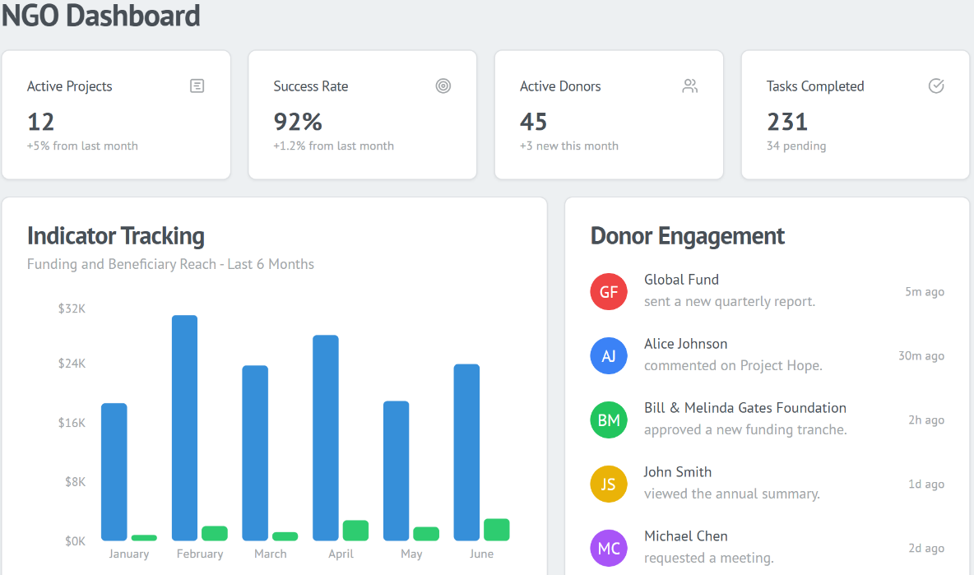

Strategic Plan
The Strategic Plan module is where your organization defines long-term direction, outcomes, and KPIs.
Viewing and Updating the Strategic Plan
- Navigate to Strategic Plan.
- Review mission, vision, and corporate objectives.
- Click Edit Plan to update content.
- Add, modify, or archive Strategic Objectives as needed.
Strategic Indicators
- Define corporate-level indicators that measure progress at the organizational level.
- These indicators feed into the Dashboard for tracking performance.
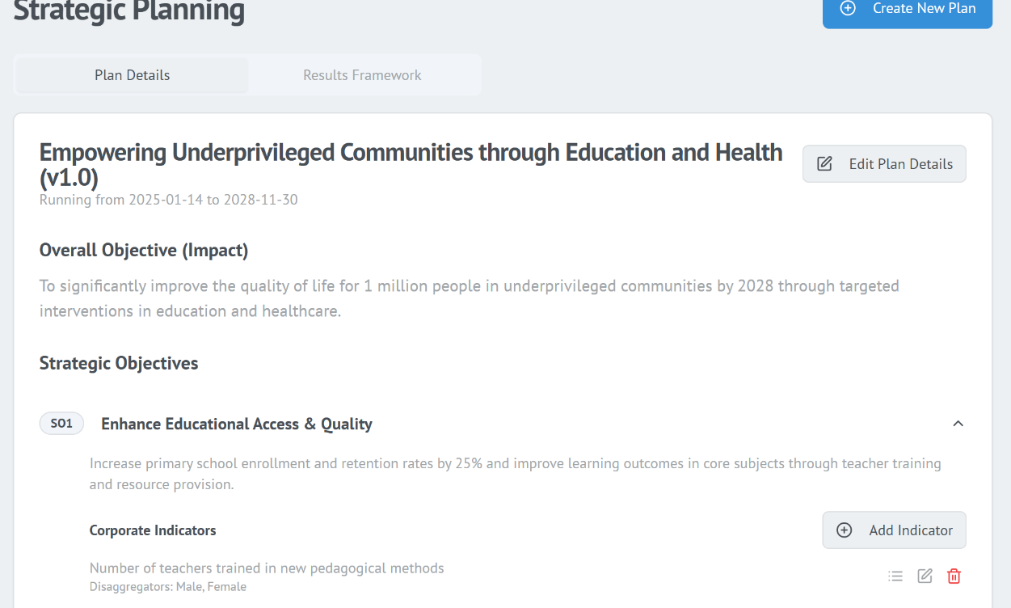

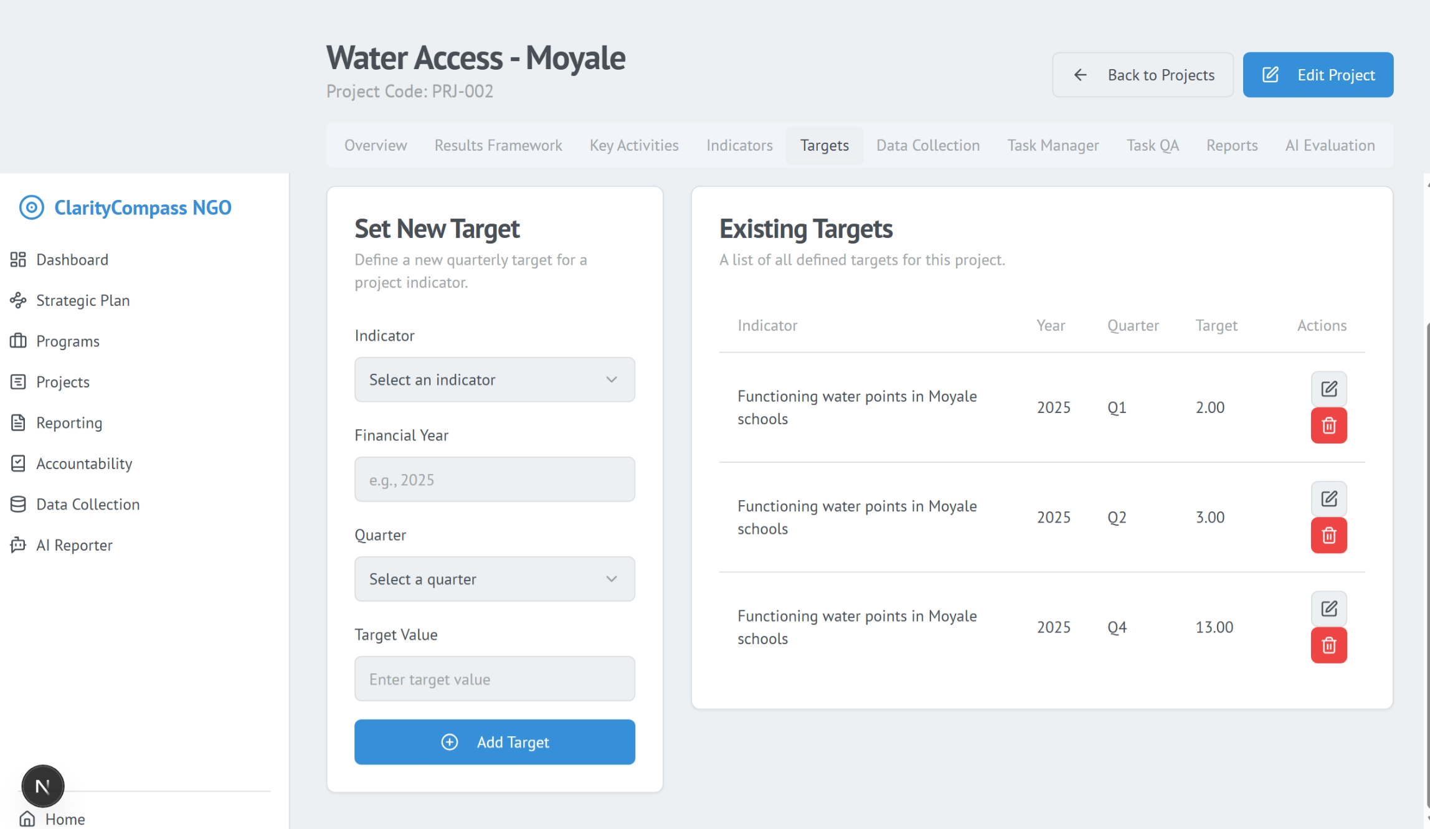

Results Framework
The Results Framework visually maps your Theory of Change.
Key Features
- Add Outcomes, Outputs, and Intermediate Results.
- Link each element to strategic objectives.
- Build logical pathways showing how activities contribute to organizational goals.
This ensures full alignment from strategy → program → project.

Programs
Programs group related projects under thematic or geographical clusters.
Creating or Editing a Program
- Navigate to Programs.
- Click Create New Program.
- Add program details.
- Link the program to one or more strategic objectives.
- Save to activate.
Programs help structure your work and provide visibility across multiple related projects.
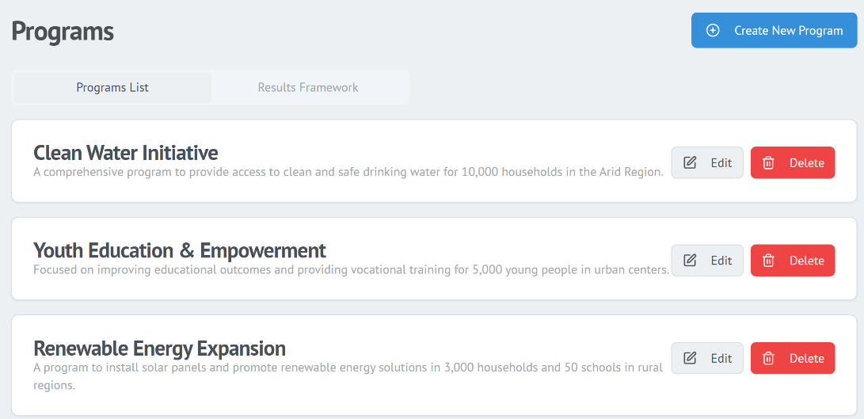

Projects
Projects are the core of daily operations in ClarityCompass.
Creating a Project
- Navigate to Projects.
- Select Create New Project.
- Fill in project details:
  - Title
  - Program
  - Duration
  - Budget
  - Team members
  - Locations
- Save to generate the project workspace.
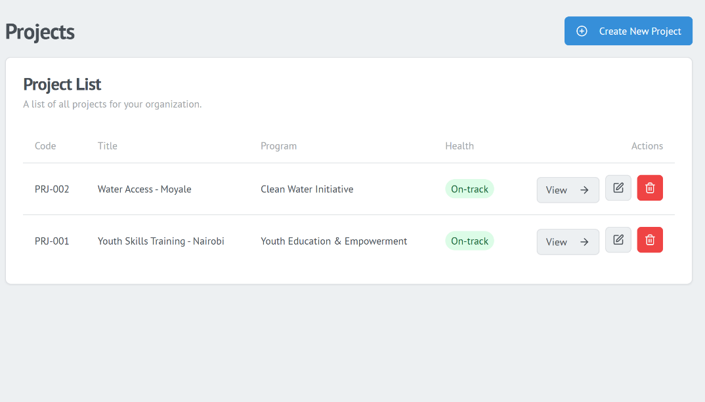

Managing an Existing Project
Click View on any project to access the project management interface.
1. Overview
- Edit project summary and details.
- Add or remove team members.
- Define geographical locations of implementation.
2. Results Framework (Project-Level)
- Add project-specific outcomes and outputs.
- Map outputs to program outcomes and organizational objectives.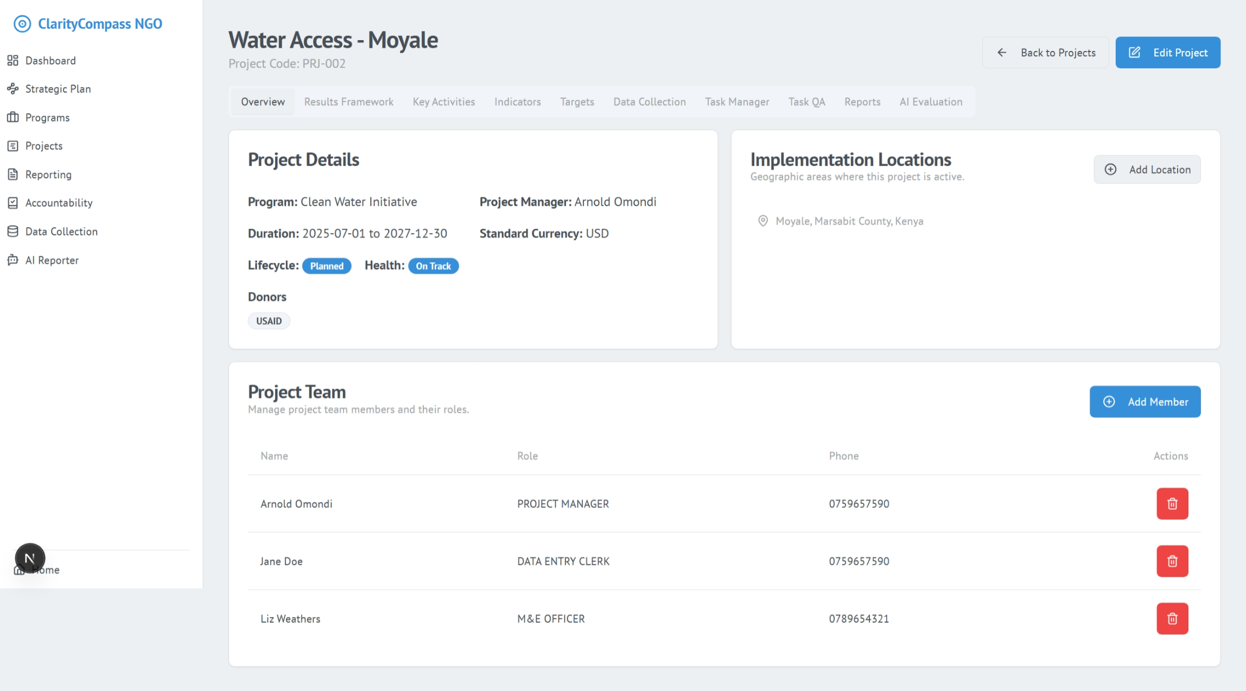

Key Activities
- Break down outputs into actionable activities.
- Assign responsibilities and timelines to team members.
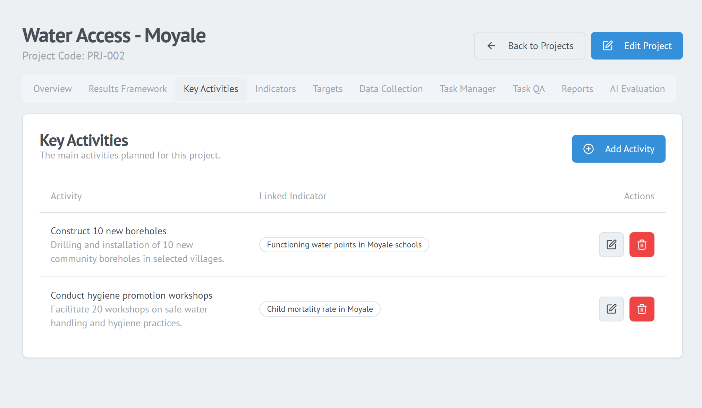

Indicators & Targets
- Define quantitative or qualitative indicators.
- Link indicators to program and strategic frameworks.
- Set quarterly or annual targets.
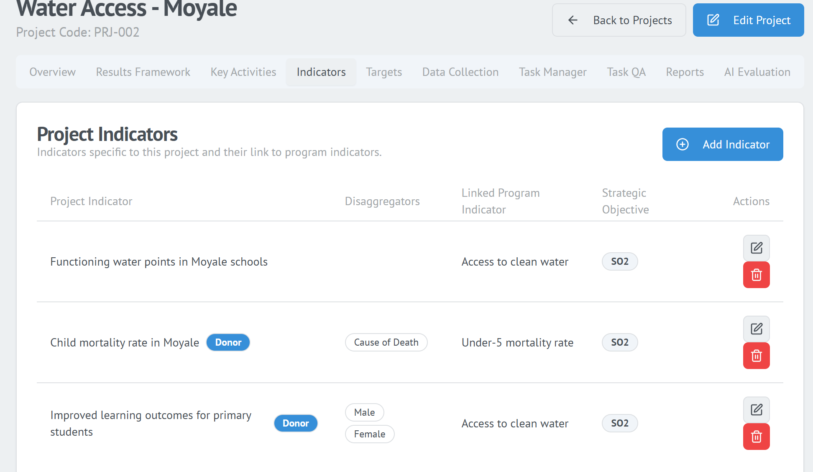

Task Manager
A calendar-based task management system.
You can:
- Create tasks under a project activity
- Assign and schedule tasks
- Mark progress and completion
- Track overdue tasks

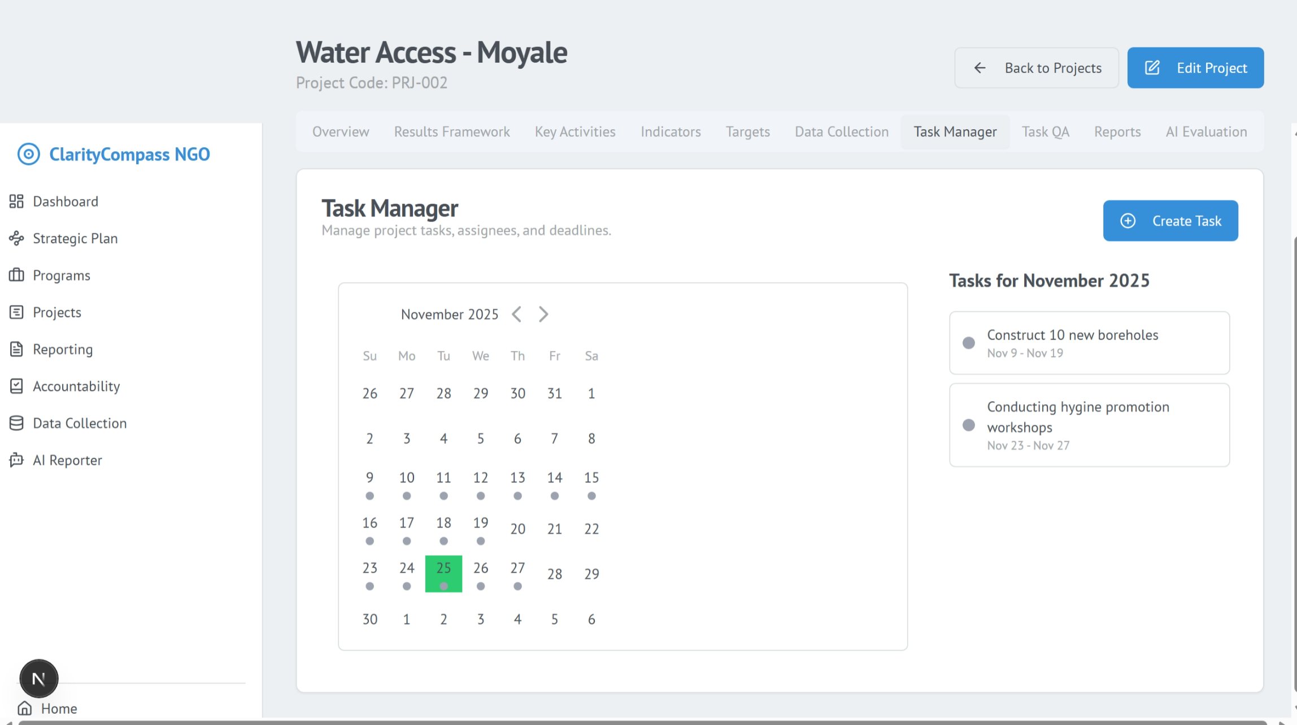

Task QA (Quality Assurance)
- Review field submissions for accuracy.
- Approve or return submissions for correction.
- Maintain high data integrity.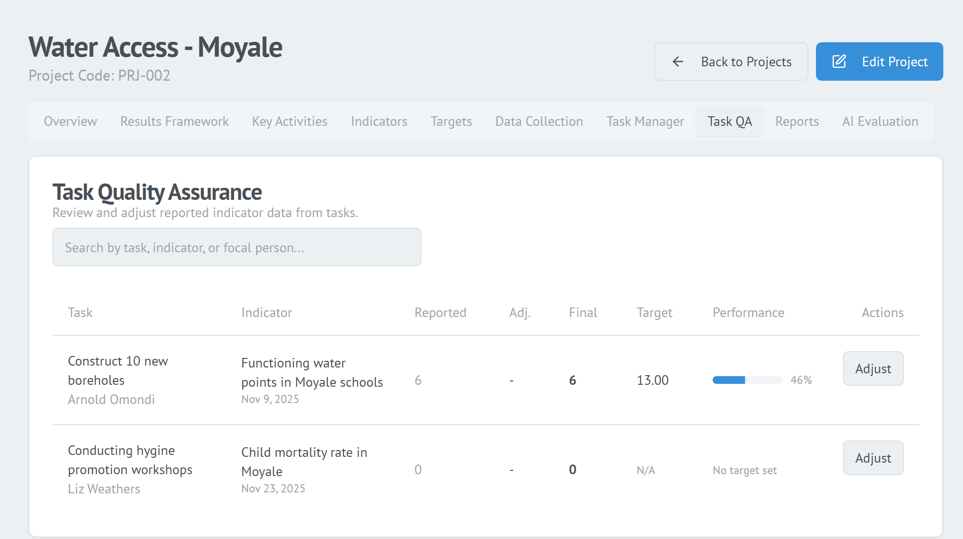

AI Reports / Evaluation
Use AI to automatically generate:
- Monthly reports
- Quarterly reports
- Project evaluations
- Summary narratives for internal or external use
You can add context such as the reporting period, target audience, or desired tone.
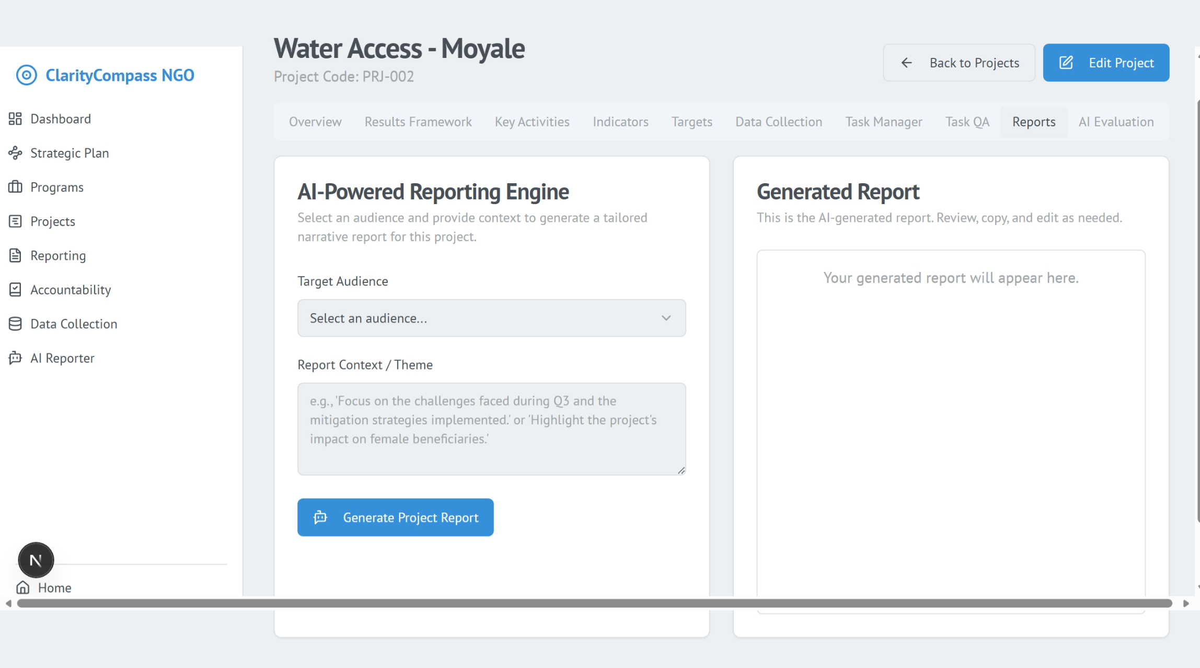

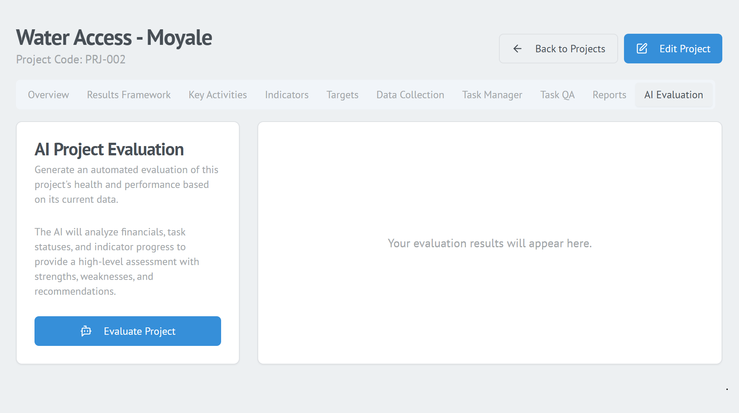

Data Collection
This module allows you to design, deploy, and manage data collection tools.
Creating a Data Collection Form
- Go to Data Collection → Create New Form.
- Add fields such as:
  - Text fields
  - Numbers
  - Dates
  - Dropdowns
  - File uploads
  - Conditional logic
- Link the form to relevant projects.
- Save and publish.
Entering Data
- Click Enter Data to fill the form manually.
- Field teams can also access forms via mobile devices.
Viewing Submissions
- Navigate to View Submissions.
- Filter submissions by date, user, or project.
- Export datasets as CSV or Excel.
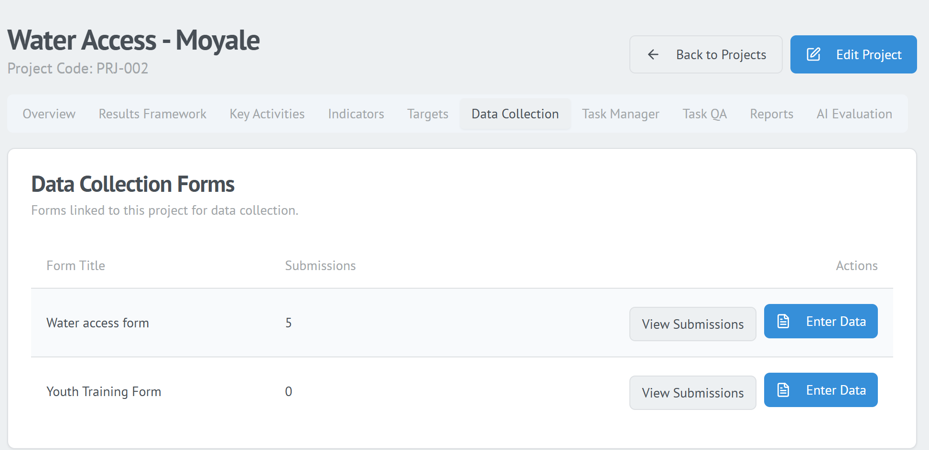

AI Reporter
The AI Reporter transforms project data into professional narrative reports.
How to Generate an AI Report
- Navigate to AI Reporter.
- Select the project.
- Choose the report type:
  - Monthly
  - Quarterly
  - Annual
  - Evaluation
- Select the target audience.
- Enter optional context or special instructions.
- Click Generate Report.
Review & Quality Check
- Download the generated report.
- Use Review to provide comments.
- Change report status (Draft, Accepted, Returned for Edits).
- Send back notes to the responsible project team.
This ensures clarity, quality, and accountability in all project reports.

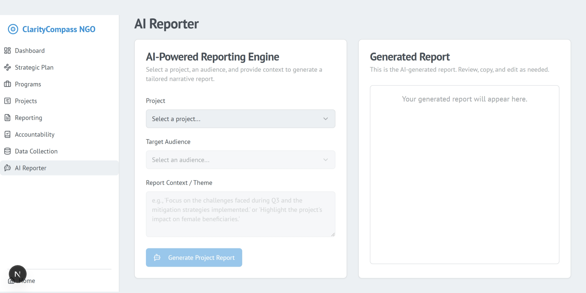

Shared Portal User Guide
The Shared Portal enables NGOs to collaborate with external partners (such as donors or oversight bodies) on proposals and reporting. It creates a transparent, traceable, and structured communication environment.

Accessing the Shared Portal
- From the home page, select Shared Portal.
- Log in using your NGO credentials.
- You will see all shared interactions, documents, proposals, and reports.

Proposal Collaboration
NGOs use this space to engage with external partners on proposal development and submission.
Key Functions
- Submit proposals developed within the NGO Platform.
- View proposal status in real time (Submitted, Under Review, Returned for Edits, Accepted).
- Receive structured feedback or clarifications.
- Resubmit after making required updates.
All changes are automatically logged for transparency.

Report Sharing
This module handles all reporting interactions between NGOs and partners.
NGOs can:
- Submit monthly/quarterly/annual reports generated in the NGO Platform.
- Upload supporting documents and evidence.
- Track report status and feedback history.
Partners can:
- Review submitted reports.
- Accept or return them with comments.
- Provide recommendations directly through the portal.
All reviews and changes remain visible for full accountability.

Communication Tools
The Shared Portal includes integrated communication features for smooth collaboration.
Tools Available
- Message Center: Structured messaging between NGO teams and partner reviewers.
- Notifications: Alerts on status changes, new comments, or requests.
- Document Exchange: Upload or download annexes, budgets, and supporting evidence.
These tools reduce email clutter and centralize all communication.

Support & Troubleshooting
Issue | Solution
Cannot log in | Use “Forgot Password” or contact admin
Forms not saving | Check mandatory fields; refresh browser
AI report errors | Regenerate with additional context
Missing dashboard data | Ensure forms and task updates are submitted
For additional help, navigate to Help → Submit a Ticket.

Glossary of Key Terms
Term | Definition
Strategic Objective | A long-term goal defined in the Strategic Plan.
Outcome | A medium-term result expected from project activities.
Output | Tangible deliverables produced by project activities.
Indicator | A measurable metric used to track progress.
Target | Expected value of an indicator within a specific time period.
Task QA | Quality assurance process for verifying task or data submissions.
Theory of Change | Logical pathway showing how activities lead to outcomes.
Shared Portal | Collaboration space for proposal and report sharing.

